Module 3 Submission

Team Name: Mexico City

Your Top 3 How Might We Questions:

- How might we help Hausverwaltungen handle repair and maintenance requests faster without replacing their existing property management software?

- How might we make communication between tenants, landlords, property managers, and service providers more transparent and less fragmented?

- How might we support small and medium-sized Hausverwaltungen with affordable AI-based automation so they can stay competitive against larger, more digital players?

Your Idea Backlog
Ideally include a screenshot of your Ideation Wall from Miro here. Alternatively, show proof that you have ideated over 30 ideas.

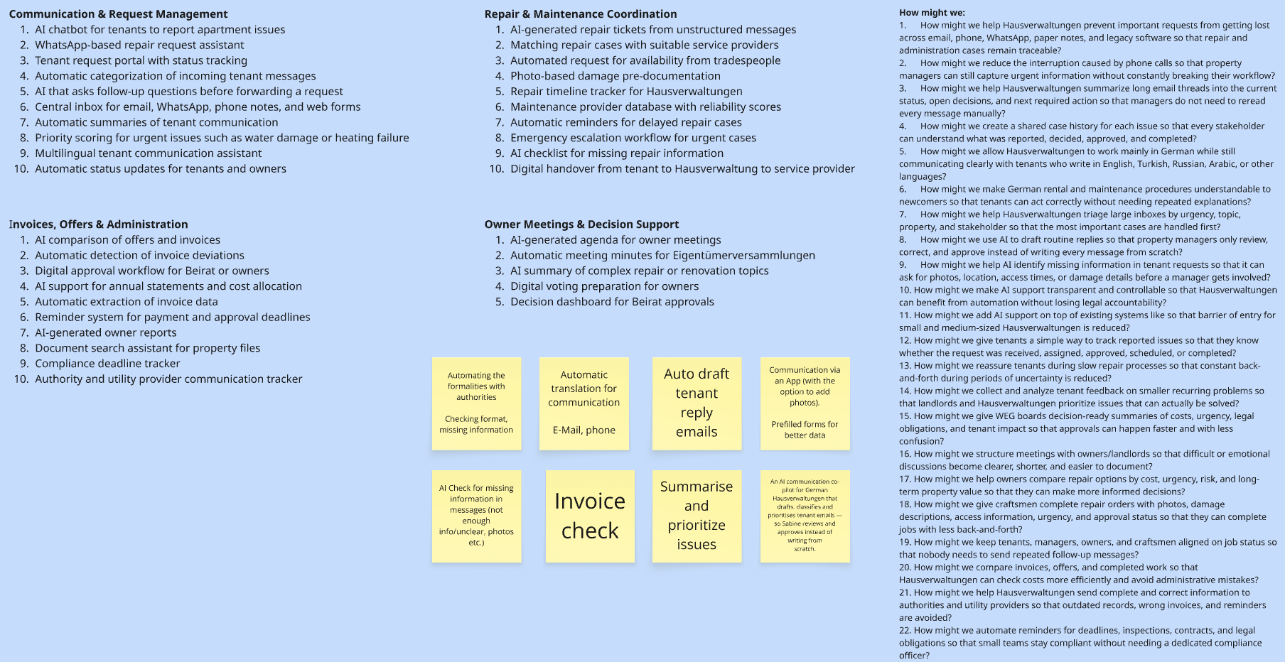

Your Chosen Idea

In one sentence:

We want to build an AI-powered maintenance request assistant that helps Hausverwaltungen collect, structure, prioritize, and track repair cases across tenants, owners, and service providers.

What is the Core Feature of Your Idea?

The core feature is an AI-based repair ticket assistant that turns unstructured messages from tenants, landlords, or owners into complete and structured maintenance tickets.

It asks follow-up questions, collects relevant information such as photos, location, urgency, and contact details, and then creates a clear ticket for the Hausverwaltung. In addition, users can also fill out the required information themselves through a structured web form.

Other features:

- Status tracking for tenants, owners, and Hausverwaltungen
- Automatic categorization of requests, e.g. heating, water damage, internet, cleaning
- Suggested priority level based on urgency
- Service provider recommendation from an existing contact pool
- Automatic summaries of communication
- Multilingual support for international tenants
- Optional owner or Beirat approval workflow for larger costs
- Integration-friendly design that does not replace existing core software

Why did you choose this idea? (2-5 sentences)

We chose this idea because our interviews showed that a large part of property management work is reactive and operational. Many repair cases and tenant requests currently arrive through fragmented channels such as phone, email, WhatsApp, or paper notes.

The idea directly addresses several pain points at once: unclear communication, missing information, repeated follow-ups, inefficient workflows, and a lack of transparency for tenants. At the same time, it does not require Hausverwaltungen to replace their existing software, which makes adoption more realistic.

We also see this as a strong starting point because the feature can be tested with a simple prototype, for example through a chatbot or structured request form, before building a full platform.

